

ST6002CEM-Mobile Application Development

Project proposal

On

NepCare: Healthcare Management Application



Submitted by: Darshan Bhusal

Coventry ID: 11782195

Batch: 32B

Module Leader: Kiran Rana

# Introduction

Welcome to NepCare, your ultimate healthcare management solution designed to revolutionize the way you access and interact with healthcare services. With NepCare, you have everything you need to take control of your health journey right at your fingertips. From booking appointments with a diverse network of healthcare professionals to accessing a comprehensive range of medications and wellness products, NepCare is your trusted companion in achieving optimal health and well-being.

# Background

In the current healthcare landscape, individuals often face numerous challenges when seeking access to essential healthcare services. Long wait times for appointments, difficulty in obtaining medications, and a lack of reliable health information are common issues encountered by patients. These barriers not only create frustration but also contribute to suboptimal health outcomes and increased healthcare costs.

# Problem Statement

The existing healthcare system is characterized by inefficiencies and obstacles that hinder individuals from receiving timely and effective care. Limited access to healthcare professionals, challenges in procuring medications, and a dearth of reliable health information exacerbate the difficulty of managing one's health effectively. These barriers not only impede individuals' ability to make informed decisions about their health but also contribute to suboptimal health outcomes.

# Project Description

NepCare is a comprehensive healthcare management platform designed to address the various challenges faced by individuals navigating the healthcare system. The project aims to develop an intuitive and user-friendly application that streamlines the process of accessing healthcare services, empowers individuals with reliable health information, and facilitates seamless communication between patients and healthcare providers.

# Aim

The aim of NepCare is to provide users with a convenient and comprehensive healthcare management solution, integrating appointment scheduling, medication purchase, and health education in one accessible platform.

# Objective

* NepCare simplifies booking appointments with diverse healthcare professionals, ensuring easy access to necessary care.
* NepCare offers seamless medication purchase, extensive catalogue selection, and doorstep delivery for enhanced user convenience.
* NepCare empowers users with curated health articles, fostering informed decisions about their health and well-being.
* NepCare fosters community engagement by providing a platform for users to discuss health issues and offer support.
* NepCare supports chronic condition management with tailored resources, tools, and services, meeting users' specific needs.
* NepCare promotes preventive healthcare through educational resources and reminders for routine check-ups, prioritizing overall wellness.

# MVVM Design Pattern

**Model:** Contains the data representation and business logic.

* AppointmentModel: Manages appointment-related data.
* MedicationModel: Handles medication-related data and operations.
* HealthArticleModel: Stores health article data.
* UserProfileModel: Manages user profile information.

**View:** Presents the user interface and interacts with the ViewModel.

* AppointmentView: Displays appointment scheduling options.
* MedicationCatalogView: Shows available medications and products for purchase.
* HealthArticleView: Displays health articles.
* UserProfileView: Shows user profile information.
* CommunityView: Provides a platform for community engagement.

**ViewModel:** Acts as an intermediary between the View and the Model, handling data manipulation and business logic.

* AppointmentViewModel: Manages appointment-related interactions between the View and AppointmentModel.
* MedicationViewModel: Handles medication-related interactions between the View and MedicationModel.
* HealthArticleViewModel: Retrieves and processes health articles data for display.
* UserProfileViewModel: Manages user profile interactions between the View and UserProfileModel.
* CommunityViewModel: Handles community-related interactions between the View and the backend server.

**Services:** Provides data access and communication with external sources.

* AppointmentService: Communicates with the backend server for appointment-related operations.
* MedicationService: Manages interactions with the medication database and facilitates purchases.
* HealthArticleService: Retrieves health articles data from the backend server.
* UserProfileService: Handles user profile data interactions with the backend server.
* CommunityService: Communicates with the backend server for community-related functionalities.

**Repository:** Acts as a bridge between the ViewModel and the data sources.

* AppointmentRepository: Abstracts data access operations for appointments.
* MedicationRepository: Handles medication data access operations.
* HealthArticleRepository: Provides an interface for fetching health articles data.
* UserProfileRepository: Manages user profile data access operations.
* CommunityRepository: Handles community-related data access operations.

**Overall Flow:**

* Views interact with ViewModels to request data and handle user interactions.
* ViewModels retrieve data from repositories or services, process it, and expose it to the views for display.
* ViewModels handle user interactions and translate them into actions to be performed by services or repositories.
* Services and repositories handle data access and manipulation, interacting with backend servers or databases as needed.
* Data flows between the various components of the application, following the MVVM pattern's separation of concerns and ensuring a clean and maintainable architecture.

# Configuration Management

**Github Link:** <https://github.com/ST60002CEM/batch32b-darshan937.git>

**Github Repository Screenshot:**

Figure 1 Github Repository

# Features

* Appointment Booking: Users can easily schedule appointments with healthcare professionals across various specialties through the NepCare app.
* Medication Catalogue: NepCare offers an extensive catalogue of pharmacy medicines and healthcare products for users to browse and purchase.
* Doorstep Delivery: Users can have their medications and healthcare products conveniently delivered directly to their doorstep.
* Health Education: NepCare provides a wealth of curated health articles covering a wide range of topics, empowering users with knowledge to make informed decisions about their health.
* Community Engagement: The platform facilitates discussions on health issues, allowing users to share tips, experiences, and support one another.

# Prototyping

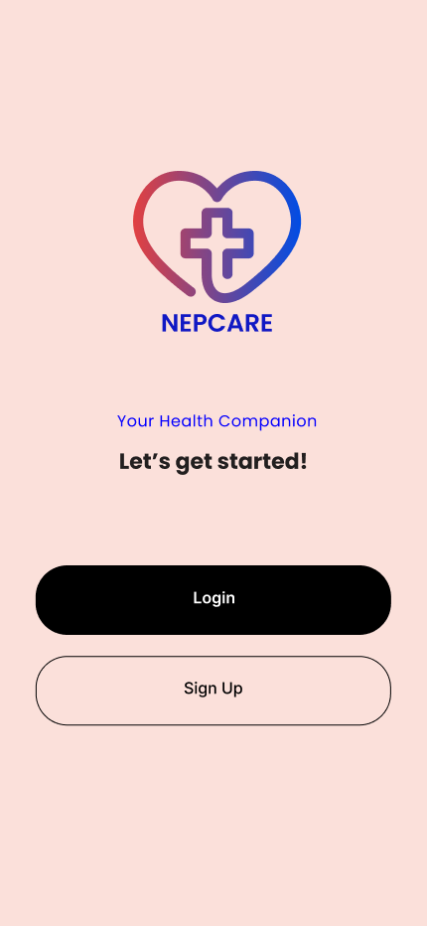 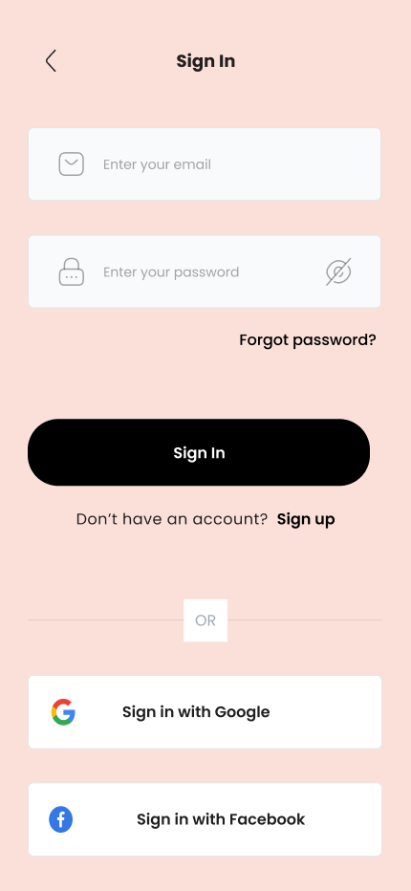 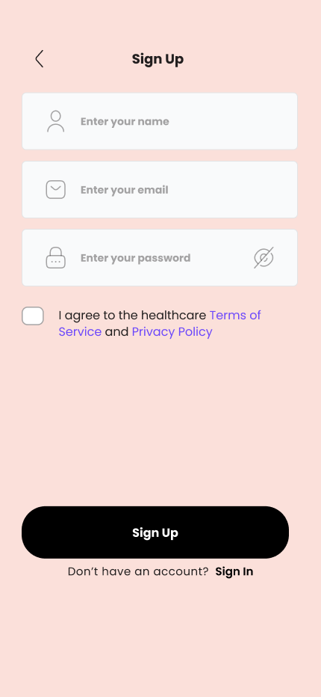

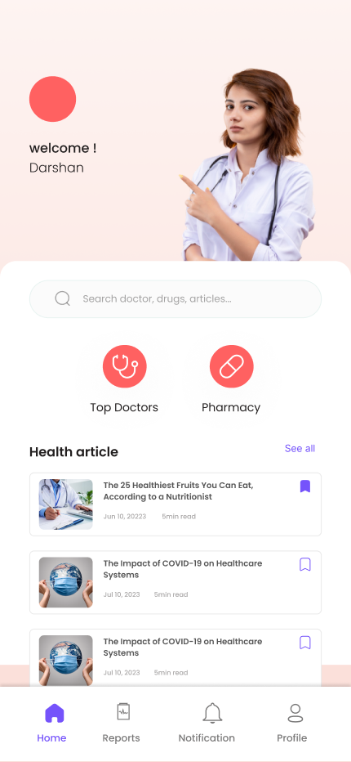

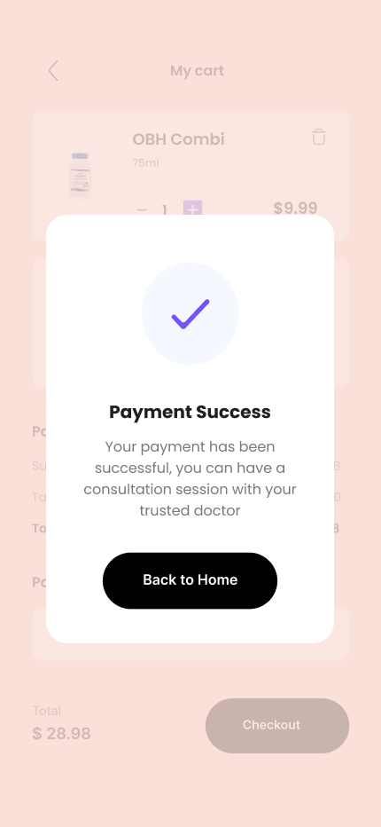

# Conclusion

In summary, NepCare revolutionizes healthcare management by providing a user-friendly platform for appointment booking, medication procurement, health education, and community engagement. With its intuitive design and robust features, NepCare empowers users to take control of their health journey with ease and convenience, ultimately promoting better health outcomes and well-being.

# References

* Free design tool: Presentations, video, social media | CANVA. (n.d.). <https://www.canva.com/>
* Figma community: Explore templates, plugins, and widgets published by the community. Figma. (n.d.-b). <https://www.figma.com/community>